Academic Year: 2025-26 | Year: Second Year | Term: I
Roll No.: 1012411011 | Name: Riddhee Kulkarni
Subject: Java
Assignment No.: 11 | Title: Client-Server application
Date: 08/10/2025

Aim:
Develop a simple client-server application using Socket and ServerSocket classes for basic
communication.
Theory:
Server Side:
On the server side, Java uses the ServerSocket class to establish a server that listens for incoming connections from clients. The server creates a ServerSocket object on a specific port number and waits for clients to connect using the accept() method. This method blocks the program until a client connects, after which it returns a Socket object that enables communication with that particular client. The server can then use input and output streams to receive data from and send data to the client. Once the communication is complete, the server can close the connection or continue to listen for more clients.
Client Side:
The client side uses the Socket class to connect to the server. The client creates a `Socket` object by specifying the server’s IP address (or hostname) and the port number on which the server is listening. Once the connection is established, the client can communicate with the server using input and output streams. The client sends data or requests to the server and receives responses in return. This setup allows the client to access resources or services provided by the server, such as retrieving information, sending messages, or performing specific operations.
Server-Client Application:
A **client-server application** in Java is a network-based program where the client and server communicate through sockets. The server continuously listens for connection requests using `ServerSocket`, and the client initiates the connection using `Socket`. After the connection is established, both can exchange data bidirectionally using streams. This model is widely used in real-world applications such as chat systems, online games, web servers, and database connections, where multiple clients interact with a centralized server to share or request information.

Flowchart:
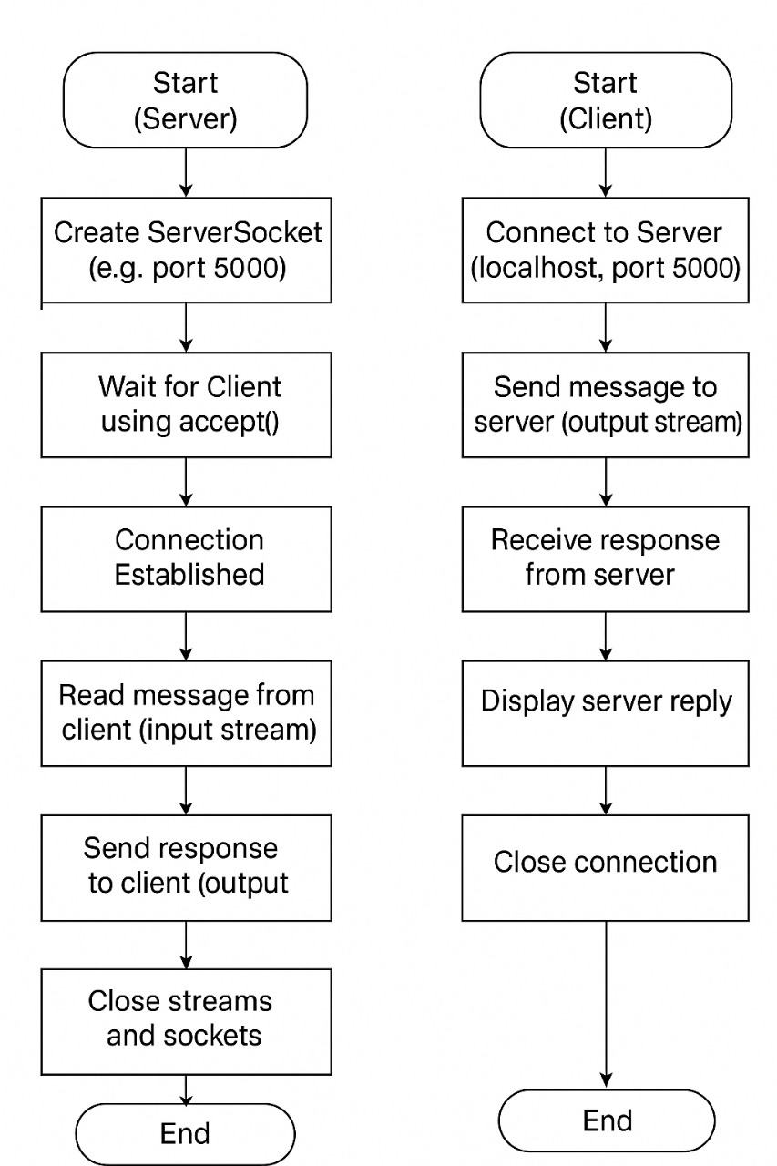

Code:
Server:
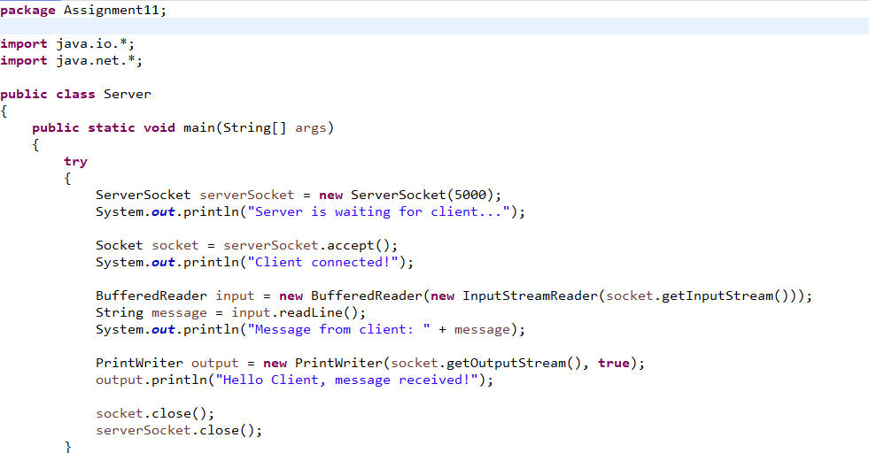
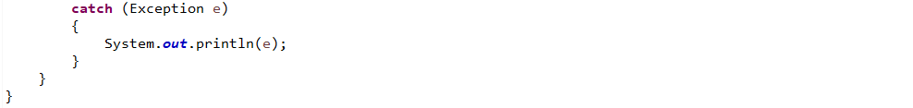
Client:
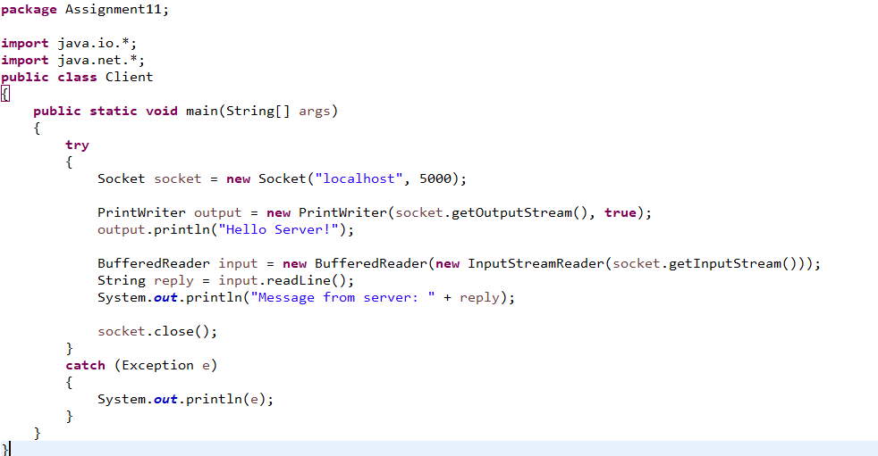

Output:
Server:
Client:
Conclusion:
A simple client-server application using Socket and ServerSocket classes for basic
communication is developed.

